Chapter Two

“Reasons to be Beautiful”

Sally Sheldon argues that ‘embodiment becomes noteworthy when it impinges on us in some way - through bodily changes, physical discomfort or when particularities in one’s form of embodiment - such as race, gender or physical abnormality - act as a disability in the context of particular social settings.’ This is why understandings of the body are important for feminism. Female bodies have acted and in many ways continue to act as a locus of discrimination.
Michel Foucault’s understandings of the relations between power, the body and sexuality have been important for feminist theory and feminism. In Discipline and Punish: The Birth of the Prison he argues for a new conceptualization of what he describes as “disciplinary power”. The key feature of disciplinary power is that it is exercised directly on the body. Disciplinary practices subject the body to a process of constant surveillance and examination that enables a continuous and pervasive control of individual conduct. According to Foucault, what is then formed is

a policy of coercions that act on the body, a calculated manipulation of its elements, its gestures, its behavior. The human body [is subject to] … a machinery of power that explores it, breaks it down and rearranges it … thus; discipline produces subjected and practiced bodies, “docile” bodies.

Certainly, Foucault’s identification of the body as the principal target of power is important for feminism, for it provides useful conceptual tools for analyzing contemporary forms of social control over female bodies.
In The History of Sexuality Foucault also argues that the body and sexuality are cultural constructs. He identifies sexuality not as ‘a kind of natural given which power tries to hold in check, or as an obscure domain which knowledge tries gradually to uncover.’ Rather, Foucault sees sexuality as a construction through which power is exercised. Foucault’s work thus ‘directs us to investigate the role of certain knowledges in shaping our conceived notions of sexuality and sexualized bodies.’
Following this logic, feminist theorists have argued that the body is not prediscursive and have challenged understandings of the body as biologically fixed. As Elizabeth Grosz argues, the body is not ‘an ahistorical, biologically given, acultural object.’ Rather, it is inscribed with meanings and these inscriptions are read on and through the body. As Moria Gatens argues,

The human body is always a signified body, and as such cannot be understood as a 'neutral object' upon which science may construct 'true discourse'. The human body and its history presuppose each other.

Certainly, throughout Western history, ideas about female bodies have had significant social, political, sexual, and economic consequences for females. Mary Evans points out that ‘we only have to examine the different ways in which male and female bodies have been constructed to recognise the impact of social expectations on the body’. The meanings inscribed on the female body produce judgments about females. Grosz, examining the history of the female body, argues that the social positions females have been forced to occupy have been “justified” by ‘containing them within bodies that are represented, even constructed, as frail, imperfect, unruly, and unreliable’. Susan Bordo also articulates this understanding of the body, explaining that it is ‘a powerful symbolic form, a surface on which the central rules, hierarchies, and even metaphysical commitments of a culture are inscribed and thus reinforced’.
More recently, feminism has come to recognise the important part that media play in constructing the female body. Bordo describes Western culture as ‘image-bedazzled’ and Sandra Lee Bartky identifies ‘the growing power of the image in a society increasingly orientated toward the visual media.’ Both writers are concerned with how representations in the media define and construct the female body. Certainly, representations of female bodies in popular media present Western culture’s idealized female body, which, as Bartky notes, is ‘small-breasted, narrow-hipped, and of a slimness bordering on emaciation; it is a silhouette that seems more appropriate to an adolescent boy or a newly pubescent girl’.
There is certainly a significant lack of female “curves” in popular representations of female bodies. Models such as Kate Moss (Fig. 2.1) and Jodie Kidd (Fig. 2.2) have become icons of a specifically late twentieth century beauty. Their adult bodies look emaciated or like a child’s. Feminist theory has linked the influence of these images of the female body to what Bartky terms the “cult of slenderness”.


Figure 2.1: Kate Moss

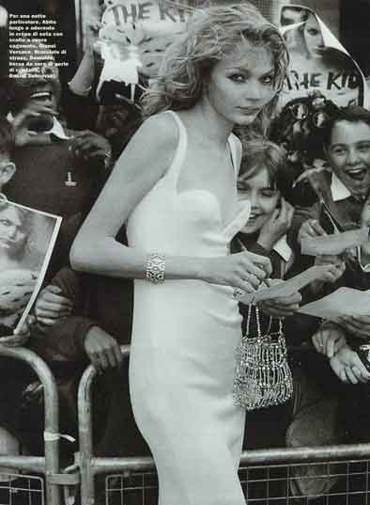
Figure 2.2: Jodie Kid

As Iris Marion Young notes, the circulation of such ideals ‘renders most women drab, ugly, loathsome, or fearful bodies’. Even though adult female bodies have hips and breasts, the size of which is largely biologically determined, as Bartky argues, those markers of the female body have become “distasteful”.
Bartky asserts that under the “tyranny of slenderness” females are “forbidden” to get large. They are to take up as little space as possible. The thin bodies represented in the media literally take up less space than both male and fully developed adult female bodies. In addition, how females are “taught” to sit, walk, and move their bodies, reinforce such restrictions. Indeed, the literature on the “cult of slenderness” suggests that it is one of the strategies by which females are subordinated to men in Western culture.
Courtney Love’s body does not conform to these “rules”. In pictures of Love, her body takes up a lot of space. It is not “contained” or “controlled” the way Western culture demands. Unlike the image of the two models (Figure 2.3) where their thin bodies are taking up very little space, their legs closed, hands behind their back or on their knees, in the image of Love (Figure 2.4) her body is “spread out”, taking up as much space as possible. As Janet Lee and Jennifer Sasser-Coen point out,

[i]n a patriarchal society, women learn quickly that their … bodies are objects of the male gaze. It is almost impossible to avoid this fact, surrounded as we are by hundreds of images of women, set up for male viewing…

The models (in Fig. 2.3) sit in a fashion that conveys their awareness that they are the objects of the audience’s gaze. The image thus reinforces to females that they are the objects of a gaze. It also teaches females how they should act in relation to this gaze - with submission. In contrast, Love’s gaze is averted, thus commanding extra space.


Figure 2.3

Figure 2.4

Although she is not returning the gaze of the audience, she challenges the controlling nature of the gaze by refusing to acknowledge it, or change her body under its scrutiny.
The developed female body is also imbued with cultural implications, which produce the female body, and females, as sexualized cultural objects. In particular, the female body is often closely linked with overt sexuality. In sources as diverse as the Christian religious texts that are held up as the moral guides for Western society, images of women used to sell commodities in advertising, and pornography, the female body is associated with sex. The bible, for example, links the female body with sexuality in the story of Adam and Eve; Eve was tempted by the pleasures of the flesh, causing both her own and Adam’s fall from divine grace. Active female sexuality is in this context understood as “dangerous”. The female body is thus a marker of sexuality, the danger of which is neutralized by constructing it as a passive object. This is how the female body is represented in contemporary pornography; it is to be gazed upon for sexual pleasure.
As such meanings are produced on and through the body, the body can also be used as a site of resistance to these meanings. The idea of the flesh being used to register such resistance is extremely useful when looking at Courtney Love. Parts of the female body have been sexually fetishized: the breasts, the hips, and the arse, and Love draws attention to this. She bares her breasts to audiences, and poses in overtly sexual positions, legs spread. (Fig. 2.5 and Fig. 2.6) In this sense, she mimics pornographic images, and focuses attention on the way in which female sexuality is objectified. In other words, she makes visible the representation of the female body in Western culture as a sexual object.

Figure 2.5

Figure 2.6

Love comments further on the ways in which female sexuality is constructed by writing on her body. The article ‘The Body as Inscriptive Surface’ by Grosz, is useful in examining how Love makes it clear that meanings associated with female sexuality are inscribed on the female body. It begins by looking at Alphonso Lingis’ ideas about tattooing and bodily inscriptions on “primitive” and “civilized” bodies. Lingis claims
that “body art” offends Western sensibilities; he suggests that Western culture considers the individual to be ‘not so much about surfaces as profound depths, subjects of hidden interiority’. Love, however, uses her body to mock this idea of interiority, and thus, the foundations of Western patriarchal discourse, by writing on it. The words she inscribes are words used to criticize female sexuality, words such as “slut”, “whore” and “bitch”. (Fig. 2.7) By writing these words on her body she draws attention to the fact that female sexuality is produced on the body, and is, furthermore, feared and hated. She points out that the female body has, for a long time in Western culture, been associated with sin and sexual danger. The negativity associated with, and the hostility directed towards female sexuality and the female body that contains and is inscribed with this sexuality, is exposed on the surface of her body.
Through such strategies, Love reveals how female sexuality has been demonized and even “taken away from” females. She reveals that while the anatomy of the female body is sexually fetishized and objectified, this body is also considered dangerous because of its sexuality. Thus, the “desirable” female body is represented as childlike (devoid of the curves that denote mature female sexuality).
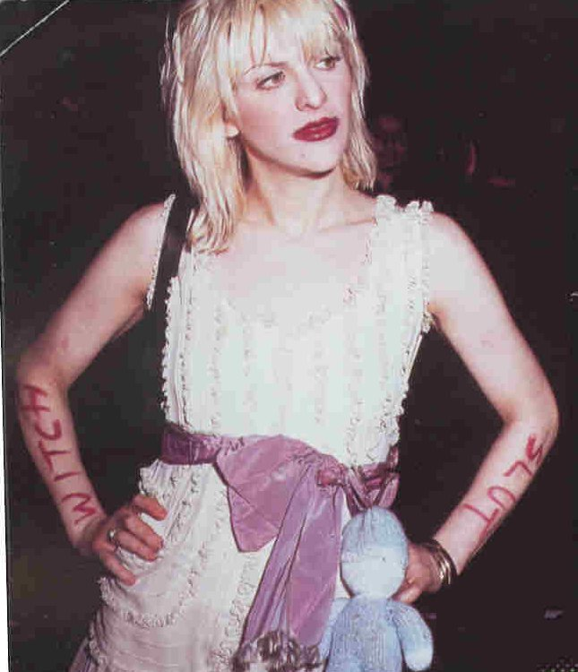
Figure 2.7 1

One of consequences of childlike representations of the female body is the sexualisation of young girls’ bodies. Catherine Lumby identifies a number of examples of this, from the magazine Dolly, to advertisements for CK jeans. Henry Giroux notes that ‘[i]n the world of Hollywood films and big name advertising, children’s sexuality closely resembles adult behaviors and privileges the adult male gaze.’ Defeminised, child-like bodies have thus become sexually desirable because, ironically, they reduce the “threat” of female sexuality.
Love’s wearing of ripped slips and little girl dresses, coupled with red lipstick and derogatory terms written on her arms and stomach, is called “pedophiliac” by Lucy O’Brien. Certainly, Love is drawing attention to the increasing tendency in Western culture to sexualize the bodies of young girls. By wearing “little girl dresses” on an obviously fully developed, adult, female body (and a body that is highly sexualised) and by mimicking childish innocence (an innocence that is clearly not there - that has been destroyed) she highlights the contradictions that surround the representation of female sexuality. (Fig. 2.8 and Fig 2.9) Love’s look has been described as a ‘fucked up Lolita’, because she uses her body as a site to witness the literal and violent consequences of the sexualisation of young girls: battered bodies. She reveals the literal consequences of this, her body often looking like ‘a fourteen-year-old battered rape victim’.
Lee and Sasser-Coen point out, girls ‘learn knowledge of how the “normal” female body should look, knowledge which varies based upon cultural and historical specificities, yet knowledge rarely created by women with women’s interests at the centre.’ Certainly, “learning” that the ideal female body is “slender” results in many females dieting to excess. As Bordo argues, ‘such preoccupation may function as one of the most powerful “normalizing” strategies of our century, ensuring the production of self-monitoring and self-disciplining “docile bodies,” sensitive to any departure from
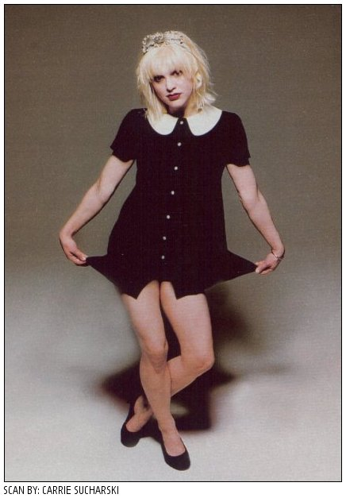
Figure 2.8
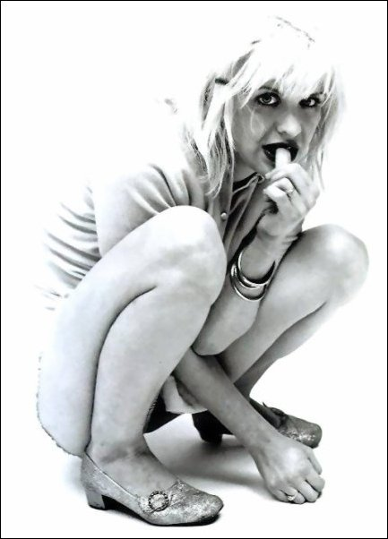
Figure 2.9
social norms’. In a sense, womanhood itself is pathologised. Breasts, hips, and other “curves” are understood as, firstly, unhealthy (a sign of being overweight) and secondly, as evidence of a dangerous sexuality. The demonisation of the female body has resulted in no one wanting a female body.
Love represents an example of a “real” female body within a media that has saturated Western vision with images of female bodies that rarely reflect the size or shape of most female bodies. As such, her body has been marked by the media as “ugly”, particularly through constant references to her weight. Love even makes an allusion to the criticisms made of her body in her lyrics, singing in ‘Plump’, ‘They say I’m plump / But I threw up all the time’.
The signification of the female body is complicated and contradictory. Different meanings are encoded on the female body, and the struggle to reconcile these on the same surface results in confusion about, fear of, and ultimately the rejection of, that body. A number of contradictions mark the representation of the sexualised female body, but the sexualised female body also contrasts with the maternal body, which has been represented throughout Western history as asexual:

Throughout patriarchal mythology, dream symbolism, theology and language, two
ideas flow side by side: one, that the female body is impure, corrupt, ... dangerous
to masculinity, a source of moral and physical contamination ... On the other hand,
as mother the woman is beneficent, sacred, pure, asexual, nourishing.

While female sexuality is encoded on the female body (and is feared and read as dangerous), the maternal body is inscribed in Western culture as asexual and pure. Females are thus pressured within Western culture to reflect this “purity” in bodies that are marked as sexually dangerous.
The criticism Courtney Love received throughout her pregnancy for her representation of "a sexualized maternal body" reveals how the maternal body is coded within Western culture as asexual. A picture of Love that appeared in Vanity Fair depicted her as heavily pregnant, in a black negligee, heavily made-up, a cigarette airbrushed out of the shot, staring directly at the camera. (Fig. 2.10) In this photograph she is returning the gaze, inviting the audience to sexualise her. Her expression mimics a “seductive come-on”- head tilted slightly forward, she gazes out from under her blonde hair, fingers curled around the airbrushed cigarette. Her maternal body is thus represented as sexual, challenging attempts to neutralize the active threat of female sexuality.
The pregnant body is understood as “evidence” of “impurity”, of active female sexuality. As Christine Morton makes clear, ‘[p]regnant bodies are neither slender nor sexualized, except as they signify sexually active (or techno-sexually active) women.’ As a result, pregnant bodies are pressured to stay hidden to conceal the signs of a dangerous, female sexuality. Love refused to hide her pregnant body, and overtly
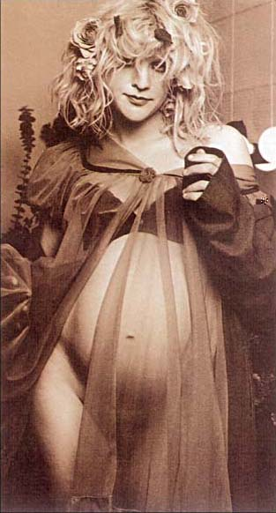
Figure 2.10

sexualized it. Consequently, much anger was directed at her and her body. While pregnant, Love was pressured to discipline her body according to the expectations of Western culture. She spoke out against this pressure, saying, ‘I don't see why I have to take on this frumpy housewife look just because I'm married and have a baby.’

Sally Sheldon points out that ‘the exploration and problematization of received understandings of the female body’ have been of central importance to feminist thinking. Such explorations have exposed the contradictions that underpin representations of the female body and female sexuality, and have suggested how such imagery impacts on female experiences of embodiment. Courtney Love, by refusing or “misusing” normative representations of the female body, by writing words such as “Slut” and “Whore” on her arms, legs and stomach, and by sexualizing both “childlike” and “maternal” bodies, also exposes the cultural contradictions underlying Western attitudes to female bodies and sexuality. The title of Love’s band Hole’s 1995-released EP is My Body, the Hand Grenade. This is an apt description of Love’s body, which she uses to fight important feminist battles on behalf of the female body.

Hole, ‘Reasons to be Beautiful’, Celebrity Skin, Geffen (1998)
Sally Sheldon, ‘The Masculine Body’, In Mary Evans and Ellie Lee (eds.), Real Bodies: A Sociological Introduction (New York: Palgrave, 2002) p. 15.
Michel Foucault, Discipline and Punish: The Birth of the Prison Trans. A. Sheridan. (Harmondsworth: Peregrine, 1977)
Ibid. pp. 138-9.
Michel Foucault, The History of Sexuality: Volume One: An Introduction Trans. Robert Hurley. (New York: Pantheon Books, 1978)
Ibid. p. 105.
Kylie Stephens, ‘Sexualized Bodies’, In Evans and Lee, Op. Cit. p. 35.
Elizabeth Grosz, Volatile Bodies: Toward a Corporeal Feminism (St Leonards: Allen & Unwin, 1994) p. 18.
Moria Gatens, ‘Power, Bodies, and Difference’, In Michéle Barrett and Anne Phillips (eds.), Destabilizing Theory: Contemporary Feminist Debate (Cambridge: Polity Press, 1992) p. 132.
For a summery of the history of female bodies see Elizabeth Grosz, ‘Refiguring Bodies’ Op. Cit. pp. 3-24; and, Rose Weitz, ‘A History of Women’s Bodies’, In The Politics of Women’s Bodies (New York; Oxford: Oxford University Press, 1998) pp. 3-11.
Mary Evans, ‘Real Bodies: An Introduction’, In Evans and Lee, Op. Cit. p. 2.
Grosz, Op. Cit. p. 13.
Susan Bordo, Unbearable Weight: Feminism, Western Culture, and the Body (Berkeley: University of California Press, 1993) p. 165.
Ibid. p. 86.
Sandra Lee Bartky, ‘Foucault, Femininity, and the Modernization of Patriarchal Power’, In Rose Weitz, Op. Cit. p. 42.
Ibid. p. 28.
Ibid. p. 85
Iris Marion Young, “The Scaling of Bodies and the Politics of Difference” Justice and the Politics of Difference (Princeton: Princeton University Press, 1990) p. 220.
Bartky, Op. Cit. p. 35.
Ibid.
Janet Lee and Jennifer Sasser-Coen, Blood Stories: Menarche and the Politics of the Female Body in Contemporary U.S Society (New York; London: Routledge, 1996) p. 9.
Weitz, Op. Cit. p.4.
Grosz, Op. Cit.
Ibid. p. 138.
Ibid.
Catherine Lumby, ‘No Kidding: Pedophilia and Popular Culture’, In Continuum: Journal of Media and Cultural Studies 12:1 (April 1998)
Henry A. Giroux, ‘Teenage Sexuality, Body Politics, and the Pedagogy of Display’, In Jonathon S. Epstein (ed.), Youth Culture: Identity in a Postmodern World (Malden; Oxford: Blackwell, 1998) p. 47.
Lucy O’Brien, ‘Final Girls: Punk, Performance Art and PMT Pop’, She Bop: The Definitive History of Women in Rock, Pop and Soul (London; New York; Ringwood; Toronto; Auckland: Penguin, 1995) p. 161.
Sheila Whiteley, Women and Popular Music: Sexuality, Identity and Subjectivity (London; New York: Routledge, 2000) p. 208.
Lynn Hirshberg, ‘Strange Love’, Vanity Fair (Sept. 1992) At www.nirvanaclub.com/interviews/vanf9209 Accessed 14/05/02.
Lee and Sasser-Coen, Op. Cit. p. 98.
Bordo, Op. Cit. p. 85.
Evan’s notes that the bodies of a large percentage of the female population (in Western culture) are larger than the female bodies represented as ideal. She explains, ‘[t]he “real” bodies are, quite literally, substantially different from those in Vogue or on a Milan fashion catwalk. We have, therefore, in terms of actual body size, a society in which real bodies and fantasized bodies are radically dissimilar.’ Op. Cit. p. 9
Hole, ‘Plump’ Live Through This Geffen, (1994)
Adrienne Rich, Of Woman Born: Motherhood as Experience and Institution (New York: Norton, 1986) Quoted in Lee and Sasser-Coen, Op. Cit. p. 13.
Hirschberg, Op. Cit.
Much criticism was directed at Love as a result of the photo. Almost as an apology to Love, in the next photo shoot that she did for Vanity Fair in 1995, Love was represented as an angel, with white wings, ethereal and pure, holding a small child.
Christine Morton, ‘The Pregnant Body in Public’, Paper originally Presented at Pacific Sociological Association 1997 Meetings, San Diego, California, April 17-20, 1997. At www.Christinemorton.com/CHM_publicpreg.htm Accessed 24/10/2003.
She became the example of bad mothering. The article that the photo accompanied made various accusations against Love, including the claim that she took heroin after she found out that she was pregnant. Subsequently, when Francis Bean Cobain was born she was removed from Love and Kurt Cobain’s care, and placed in the custody of Love’s half sister. Poppy Brite, Courtney Love: The Real Story (London: Orion, 1997) pp. 137-142.
Amy Raphael, Face, Feb 1993. At www.angelfire.com/tx5/brookesalbumcovers/articles2/facefeb93.html Accessed 24/07/2002.
Sheldon, Op. Cit. p. 14.

